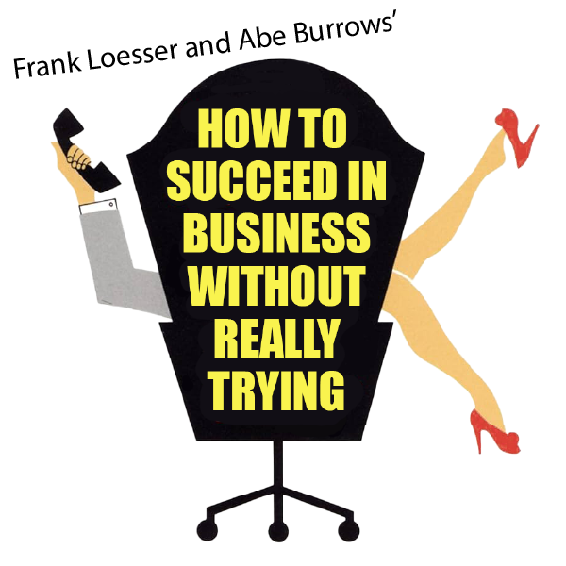

APRIL 18, 19, 25, & 26 at 2 PM
APRIL 18, 22, & 25 at 7:30 PM

Non-Profit Org.
U.S. Postage
PAID
Permit No. 271
Media, PA 19063

Rose Valley Chorus & Orchestra
P.O. BOX 414
Media, PA 19063

Return Service Requested


ORDER FORM – AUTUMN 2025 ONLY

Tickets are valid for any performance of the show. Door prices are the same as advanced sales. All seating is General Admission.
NUMBER OF TICKETS PRICE PER TICKET TOTAL
____ Adults $25 $_______________
____ Students/Seniors 60+ $20 $_______________
____ Children (12 and under) $10 $_______________

SPONSORSHIP - Please consider a tax-deductible contribution for which you will receive complimentary tickets and your name listed in the playbill. All submissions must be received no later than October 24, 2025.
Level: Contribution: Comp Tickets:
Angel $500 10
Star $250 5
Benefactor $150 3
Patron $100 2
Friend $50 1
Name in Playbill:
(Please print this information)
TOTAL ENCLOSED FOR THIS ORDER: $

Name
Address

Phone
Email

Send your check, this form, and a stamped, self-addressed envelope to:
ROSE VALLEY CHORUS & ORCHESTRA ● P.O. BOX 414 ● MEDIA, PA 19063
PRESENTING OUR UPCOMING SHOWS IN 2026!

SPRING 2026
Frank Loesser and Abe Burrow’s
How to Succeed in Business Without Really Trying
Book by Abe Burrows, Jack Weinstock and Willie Gilbert
Music and Lyrics by Frank Loesser
Based upon the book by Shepherd Mead
Stage Direction by Chris Fitting Music Direction by Florrie Marks

Originally presented by Cy Feuer and Erenest H. Martin in Association with Frank Productions.

AUTUMN 2025
Gilbert & Sullivan’s THE GRAND DUKE
Book by W. S. Gilbert
Music by Authur Sullivan

Stage Direction by Julie May
Music Direction by Florrie Marks

We encourage you to purchase tickets through our website.
Show your emailed receipt or purchase tickets at the door!


www.rvco.org

For more information, please call 484-891-9801 and leave a message,
or email tickets@rvco.org and/or sponsorship@rvco.org.

To place an ad in our playbill, inquire by October 19 at ads@rvco.org.

PERFORMANCE SITE

The Auditorium at Strath Haven Middle School
200 South Providence Road (PA-Route 252)
Wallingford, PA 19086

